Calculating Daily Returns - Explanation

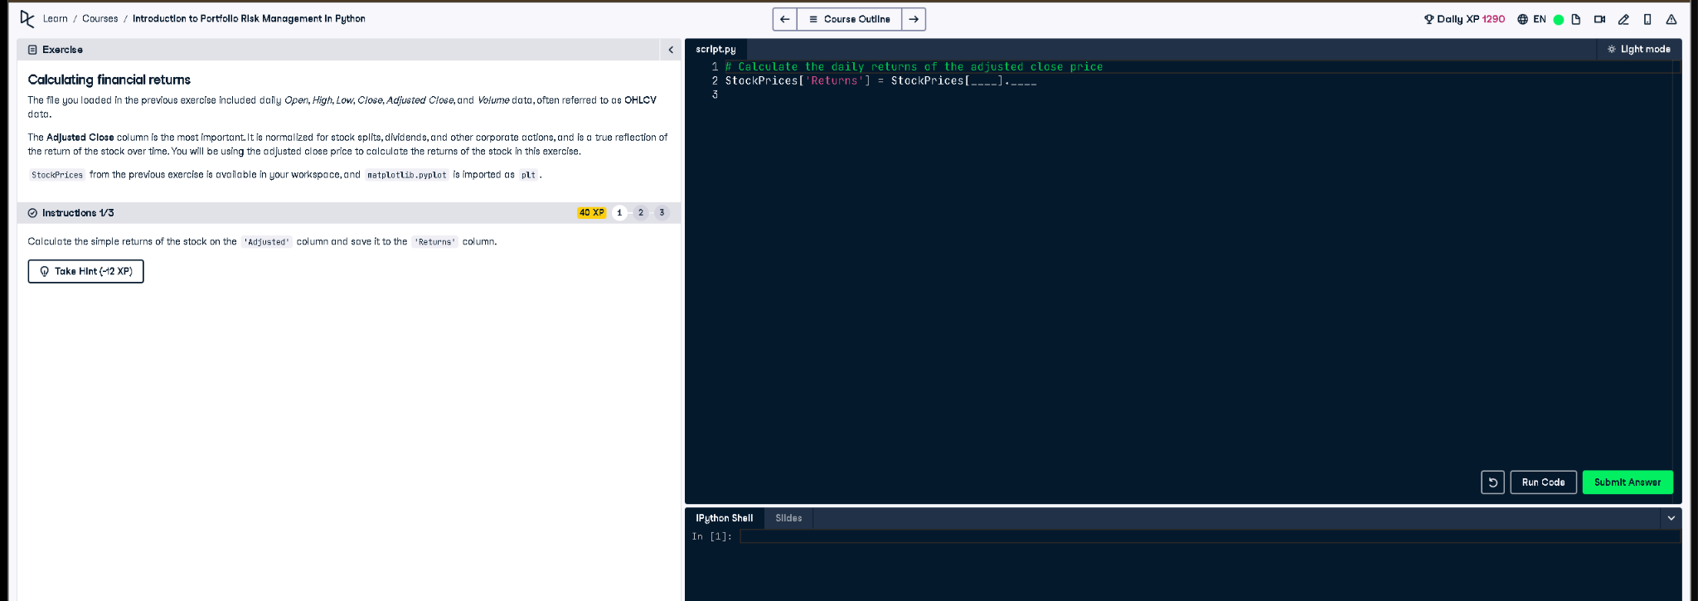

# Python Code

# Calculate the daily returns of the adjusted close price  
StockPrices['Returns'] = StockPrices['Adjusted'].pct_change()

# Explanation (in simple words)

This code calculates the stock’s daily simple return using the 'Adjusted' column. It uses the .pct_change() function to get the percent change from one day to the next, and stores the result in a new column called 'Returns'.